**DAA [Day 1]**

UID: 24MCI10204

Name: Rahul Saxena

Branch: 24MCA – AI & ML

**Question 1:**

1. Develop Sparse Matrix using Linked List.
2. Traverse Matrix in Spiral Manner.

**Answer:**

**Develop Sparse Matrix Using Linked list**

class Node {

int row, col, val;

Node next;

Node(int row, int col, int val) {

this.row = row;

this.col = col;

this.val = val;

this.next = null;

}

}

public class SparseMatrixLinkedList {

static Node head = null;

static void insert(int row, int col, int val) {

if (val == 0) return;

Node newNode = new Node(row, col, val);

if (head == null) {

head = newNode;

} else {

Node temp = head;

while (temp.next != null)

temp = temp.next;

temp.next = newNode;}}

static void display() {

System.out.println("Row Col Value");

Node temp = head;

while (temp != null) {

System.out.println(temp.row + " " + temp.col + " " + temp.val);

temp = temp.next;}}

public static void main(String[] args) {

int[][] matrix = {

{0, 0, 3, 0, 4},

{0, 0, 5, 7, 0},

{0, 0, 0, 0, 0},

{0, 2, 6, 0, 0}

};

for (int i = 0; i < matrix.length; i++)

for (int j = 0; j < matrix[0].length; j++)

insert(i, j, matrix[i][j]);

display(); }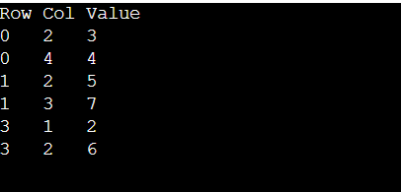}

**Output:**

**Traverse Matrix in Spiral Manner**

public class SpiralMatrix {

static void spiralTraverse(int[][] mat) {

int top = 0, bottom = mat.length - 1;

int left = 0, right = mat[0].length - 1;

while (top <= bottom && left <= right) {

for (int i = left; i <= right; i++)

System.out.print(mat[top][i] + " ");

top++;

for (int i = top; i <= bottom; i++)

System.out.print(mat[i][right] + " ");

right--;

if (top <= bottom) {

for (int i = right; i >= left; i--)

System.out.print(mat[bottom][i] + " ");

bottom--;

}

if (left <= right) {

for (int i = bottom; i >= top; i--)

System.out.print(mat[i][left] + " ");

left++;

}

}

}

public static void main(String[] args) {

int[][] matrix = {

{1, 2, 3, 4},

{5, 6, 7, 8},

{9, 10, 11, 12},

{13, 14, 15, 16}

};

System.out.print("Spiral Order: ");

spiralTraverse(matrix);

}

}

**Output:**

**Question 2:** Simulate Music Playlist using Circular Doubly Linked List

**Answer:**

class Song {

String title;

Song prev, next;

Song(String title) {

this.title = title;

this.prev = this.next = null;

}

}

public class Playlist {

static Song tail = null;

static void addSong(String title) {

Song newSong = new Song(title);

if (tail == null) {

newSong.next = newSong.prev = newSong;

tail = newSong;

} else {

newSong.next = tail.next;

newSong.prev = tail;

tail.next.prev = newSong;

tail.next = newSong;

tail = newSong;

}

}

static void playForward() {

if (tail == null) return;

Song temp = tail.next;

do {

System.out.println("Playing: " + temp.title);

temp = temp.next;

} while (temp != tail.next);

}

static void playBackward() {

if (tail == null) return;

Song temp = tail;

do {

System.out.println("Playing: " + temp.title);

temp = temp.prev;

} while (temp != tail);

System.out.println("Playing: " + temp.title);

}

public static void main(String[] args) {

addSong("Song A");

addSong("Song B");

addSong("Song C");

System.out.println("Playlist Forward:");

playForward();

System.out.println("\nPlaylist Backward:");

playBackward();

}

}

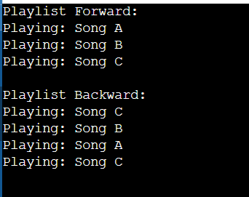**Output:**